An InternshipReport

on

**Process Mining Virtual Internship**

Submitted in partial fulfilment of the requirements

for the award of the degree of

**BACHELOR OF TECHNOLOGY**

in

**Computer Science and Engineering (Data Science)**

by

**B.SABREEN TAJ (214G1A3289)**

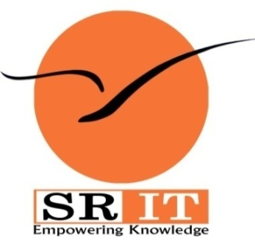

**DEPARTMENT OF COMPUTER SCIENCE AND ENGINEERING (DATA SCIENCE)**

**SRINIVASARAMANUJANINSTITUTEOFTECHNOLOGY**

**(AUTONOMOUS)**

**(AffiliatedtoJNTUA,accreditedbyNAACwith‘A’Grade,ApprovedbyAICTE,NewDelhi& AccreditedbyNBA (EEE,ECE&CSE))**

**Rotarypuramvillage,BKSamudramMandal, Ananthapuramu-515701.**

**2023-2024**

**SRINIVASARAMANUJANINSTITUTEOFTECHNOLOGY (AUTONOMOUS)**

**(AffiliatedtoJNTUA,accreditedbyNAACwith‘A’Grade,ApprovedbyAICTE,NewDelhi& AccreditedbyNBA (EEE,ECE&CSE))**

**Rotarypuramvillage,BKSamudramMandal, Ananthapuramu-515701.**

**Department of Computer Science & Engineering (Data Science)**

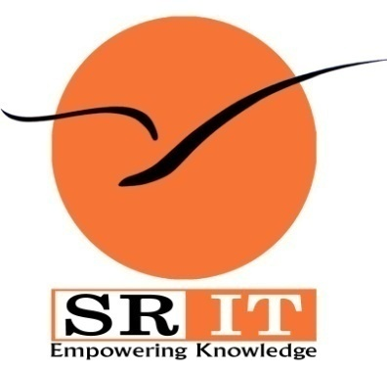

**Certificate**

This is to certify that the internship report entitled“Process Mining Virtual Internship” is the bonafide work carried out by **B.SABREEN TAJ** bearing Roll Number 214G1A3289 in partial fulfilment of the requirements for the award of the degree of **Bachelor of Technology** in **Computer Science and Engineering (Data Science)**for three months from May 2023 to July 2023.

**Internship Coordinator Head of the Department**

Mr. P. Veera Prakash, M.Tech., (Ph.D.), Dr. P. Chitralingappa, M.Tech., Ph.D.,Assistant Professor& HOD of CSE Associate Professor

Date:  **EXTERNAL EXAMINER**

Place: Ananthapuramu

**PREFACE**

Brief overview of the company’s history:

The term "Process mining" was first coined in a research proposal written by the Dutch computer scientist [Wil van der Aalst](https://en.wikipedia.org/wiki/Wil_van_der_Aalst). Thus began a new field of research that emerged under the umbrella of techniques related to data science and process science at the [Eindhoven University](https://en.wikipedia.org/wiki/Eindhoven_University_of_Technology) in 1999. In the year 2000, the very first practically applicable algorithm for process discovery, "[Alpha miner"](https://en.wikipedia.org/wiki/Alpha_algorithm) was developed.  in 2001, a much similar algorithm based on heuristics called "[Heuristic miner](https://www.researchgate.net/publication/229124308_Process_Mining_with_the_Heuristics_Miner-algorithm)" was introduced in the research papers. The year 2004 earmarked the development of "[Token-based replay](https://en.wikipedia.org/wiki/Token-based_replay)" for conformance checking purposes.  the discovery and development of "[Performance analysis](https://en.wikipedia.org/w/index.php?title=Performance_analysis_in_process_mining&action=edit&redlink=1)", "[Decision mining](https://www.researchgate.net/publication/221585988_Decision_Mining_in_ProM)" and "[Organizational mining](https://en.wikipedia.org/w/index.php?title=Organisational_mining&action=edit&redlink=1)" in the year 2005 and 2006 respectively. In the year 2007, the first-ever commercial process mining company "Futura Pi" was established. a governing body was formed in the year 2009 that began to overlook the norms and standards related to process mining.  Further techniques were developed for conformance checking which led to the publishing of "[Alignment-based conformance checking](https://link.springer.com/chapter/10.1007/978-3-662-45563-0_1)" in the year 2010. In 2011, the first-ever Process mining book was published. Further along in 2014, a [MOOC](https://en.wikipedia.org/wiki/Mooc) course was offered by [Coursera](https://en.wikipedia.org/wiki/Coursera) on Process mining. By the year 2018, nearly 30+ commercially available process mining tools were in the picture. The year 2019 earmarked the first Process mining conference. Today we have over 35 vendors offering tools and techniques for process discovery and conformance checking.Today ,several software companies offer process mining solutions to assist business in uncovering insights and improving efficiency.

* Who founded it

Professor Wil van der Aalst

* What purpose and when

Process mining applies data science to discover, validate and improve workflows. By combining data mining and process analytics, organizations can mine log data from their information systems to understand the performance of their processes, revealing bottlenecks and other areas of improvement. The term "Process mining" was first coined in a research proposal written by the Dutch computer scientist Wil van der Aalst. Thus began a new field of research that emerged under the umbrella of techniques related to data science and process science at the Eindhoven University in 1999.

Company’s Mission Statement:

Help companies improve efficiency (and reduce waste) by providing a modern way to run business processes entirely on data and intelligence.The general purpose of process mining companies is to provide innovative solutions and tools that enable organisations to gain valuable sights into their business processes and achieve intelligence.

Business Activities:

Process mining focuses on different perspectives, such as control-flow, organizational, case, and time. While much of the work around process mining focuses on the sequence of activities—i.e. control-flow—the other perspectives also provide valuable information for management teams.

**ACKNOWLEDGEMENT**

The satisfaction and euphoria that accompany the successful completion of any task would be incomplete without the mention of people who made it possible, whose constant guidance and encouragement crowned our efforts with success. It is a pleasant aspect that I have now the opportunity to express my gratitude for all of them.

It is with immense pleasure that I would like to express my indebted gratitude to my internship coordinator**Mr. P. Veera Prakash,Assistant Professor& HOD,Department of Computer Science and Engineering**,who has supported me a lot and encouraged me in every step of the internship work. I thank him for the stimulating support, constant encouragement and constructive criticism which have made possible to bring out this internship work.

I am very much thankful to **Dr. P. Chitralingappa, Associate Professor & HOD, Computer Science and Engineering (Data Science),** for his kind support and for providing necessary facilities to carry out the work.

I wish to convey my special thanks to **Dr. G. Balakrishna, Principal** of **Srinivasa Ramanujan Institute of Technology**for giving the required information in doing my internship. Not to forget, I thank all other faculty and non-teaching staff, and my friends who had directly or indirectly helped and supported me in completing my internship in time.

I also express our sincere thanks to theManagementfor providing excellent facilities and support**.**

Finally, I wish to convey my gratitude to my family who fostered all the requirements and facilities that I need.

**B.SABREEN TAJ**

**(214G1A3289)**

**INDEX**

|  |  |  |
| --- | --- | --- |
| **Contents** | | **Page No.** |
| **List of Figures** | | vi |
| **List of Tables** | | vii |
| **List of Abbreviations** | | viii |
| **Nomenclatures** | | ix |
| Chapter 1 | Introduction. | 1 |
| Chapter 2 | Technology. | 4 |
| Chapter 3 | Applications. |  |
| Chapter 4 | Modules Explanation |  |
| Chapter 5 | Real time examples of process mining  . |  |
| Chapter 6 | Learning outcomes of the Internship: |  |
| Conclusion | | 33 |
| Internship certificate: | | 34 |
| References | |  |

**LIST OF FIGURES**

|  |  |  |
| --- | --- | --- |
| **Fig. No.** | **Description** | **Page No.** |
| 3.1 | Outage in linear networks | 18 |
| 4.1 | Output | 39 |
| 4.2 | Outage probability for Existing and Proposed system | 40 |

|  |  |  |
| --- | --- | --- |
|  |  |  |
|  |  |  |

**LIST OF ABBREVIATIONS**

**(Ascending order)**

CBR Constant Bit Rate

CSI ChannelState Information

EPA Equal Power Allocation

IEEE Institute for Electrical and Electronic Engineers

MANET Mobile Ad-hoc Network

NS-2Network Simulator-2

OPA Optimal Power Allocation

OR-ICSI Optimal Routing –Instantaneous ChannelState Information

OR-MCSI Optimal Routing –Mean Channel State Information

SNR Signal Noise Ratio

WMAN Wireless Metropolitan Area Networks

**CHAPTER 1**

**INTRODUCTION**

**What is process mining?**

Process mining applies data science to discover, validate and improve workflows. By combining data mining and process analytics, organizations can mine log data from their information systems to understand the performance of their processes, revealing bottlenecks and other areas of improvement. Process mining leverages a data-driven approach to process optimization, allowing managers to remain objective in their decision-making around resource allocation for existing processes.Information systems, such as Enterprise Resource Planning (ERP) or Customer Relationship Management (CRM) tools, provide an audit trail of processes wih their respective log data.

**Types of process mining**

Wil van der Aalst, a Dutch computer scientist and professor, is credited with much of the academic research around process mining. Both his research and the above-mentioned manifesto describe three types of process mining, which are discovery, conformance, and enhancement.

**Discovery:** Process discovery uses event log data to create a process model without outside influence. Under this classification, no previous process models would exist to inform the development of a new process model. This type of process mining is the most widely adopted.

**Conformance:** Conformance checking confirms if the intended process model is reflected in practice. This type of process mining compares a process description to an existing process model based on its event log data, identifying any deviations from the intended model.

**Enhancement**: This type of process mining has also been referred to as extension, organizational mining, or performance mining. In this class of process mining, additional information is used to improve an existing process model. For example, the output of conformance checking can assist in identifying bottlenecks within a process model, allowing managers to optimize an existing process.

**Why is process mining important?**

Increasing sales isn’t the only way to generate revenue. Six sigma and lean methodologies also demonstrate how the reduction of operational costs can also increase your return-on-investment (ROI). Process mining helps businesses reduce these costs by quantifying the inefficiencies in their operational models, allowing leaders to make objective decisions about resource allocation. The discovery of these bottlenecks can not only reduce costs and expedite process improvement, but it can also drive more innovation, quality, and better customer retention. However, since process mining is still a relatively new discipline, it still has some hurdles to overcome. Some of those challenges include:

* **Data Quality:** Finding, merging and cleaning data is usually required to enable process mining. Data might be distributed over various data sources. It can also be incomplete or contain different labels or levels of granularity. Accounting for these differences will be important to the information that a process model yields.
* **Concept drift:** Sometimes processes change as they are being analyzed, resulting in concept drift.

**What is the role of process mining?**

Process mining can assist an organization in discovering, improving, and monitoring processes. It enhances competitiveness through a better understanding of internal processes and applying the insights to identify process enhancement opportunities.

Process mining makes use of event data to gain insight into operations, check for conformance pertaining to predefined process models, and enhance models using information pertaining to resource usage, bottlenecks, and decisions. Process mining does not concentrate strictly on process management and instead provides a transparent, holistic perspective of all the organization’s activities, ultimately creating a dynamic system that could reflect modifications in real time. This ensures that businesses have the opportunity to incorporate data from other sources, proactively mitigating the risks from components in transit. When provided with the data, process mining could evolve into a laboratory to explore areas in which hypotheses are tested and forecasts are sharpened.

In process mining, a process is sequence of events (discrete actions) that are executed to reach a particular goal or outcome.

For example, we can characterise each patient's hospital journey as a process, starting from when they are admitted to when they are discharged.

Characteristics of Process Mining tools:

Generate process maps capturing different process variants with the sequence of tasks/steps involved. Extract relevant business insights such as process discovery, root cause analysis, process conformance checks and process benchmarking

**CHAPTER 2**

**TECHNOLOGY**

Process mining applies data science to discover, validate and improve workflows. By combining data mining and process analytics, organizations can mine log data from their information systems to understand the performance of their processes, revealing bottlenecks and other areas of improvement.

* ***Performance Analysis***: Used when there is an *a priori* model. The model is extended with additional performance information such as processing times, cycle times, waiting times, costs, etc., so that the goal is *not* to check conformance, but rather to improve the performance of the existing model with respect to certain process performance measures. An example is the extension of a process model with performance data, i.e., some prior process model dynamically annotated with performance data. It is also possible to extend process models with additional information such as decision rules and organisational information (e.g., roles).

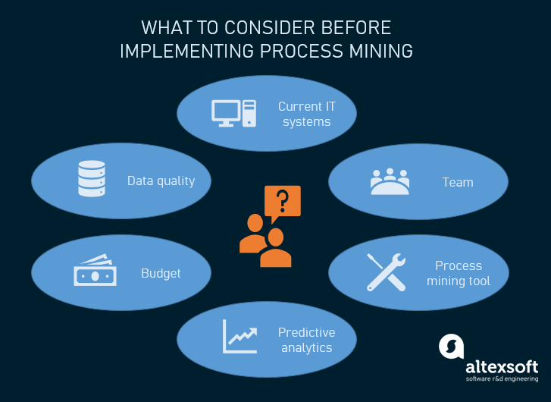

**Fig 2.1 TECHNOLOGY OF PROCESS MINING**

The three main advanced techniques to extract knowledge from event logs and other sources of process data.

It involves in mainly three steps : 1)Data Extraction 2)Process Discovery 3)Process Enhancement

1)**Data Extraction** : It involves in collecting event data from various sources,such as enterprises systems or logs.

2)**Process Discovery** : It uses algorithms to create process models based on the collected data,visualizing the actual process flow.

3)**Process Enhancement** : It aims to identify bottlenecks,inefficies,and oppurtunities for improvement in the process.

Various techniques ,such as process conformance checking and performance analysis,are used to analyze and optimize the process based on the extracted data. Overall ,process mining combines data science, machine learning and provide process management.

Process Mining. Relevant to security considerations, process mining techniques analyze and extract process-related information from (process) event logs

**CHAPTER 3**

**APPLICATIONS**

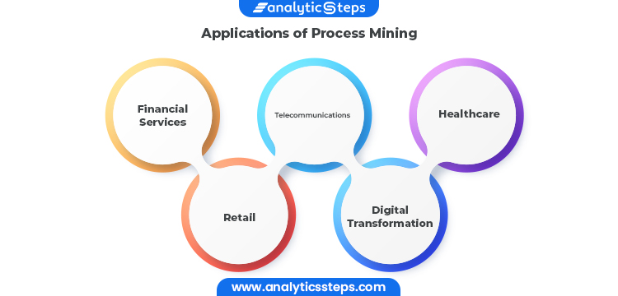

**Fig 3.1 APPLICATIONS OF PROCESS MINING**

### ****1.Financial Services:****

Because of the rise in transaction volume and the digitization of more industries, aberrant activity is harder to detect using manual methods. Companies in the financial services sector have the chance to continually and thoroughly identify issues within high-volume processes thanks to process mining, which is a solution to the increased regulatory and audit requirements.

**2.Telecommunications:**

 As subscriber quantities increase and activations become more and more automated, there is a greater danger of unsuccessful activations. When telecom companies get more orders, process mining gives them the chance to identify pricey issues and client blowback in their Order-to-Activation processes.

### ****3.Healthcare:****

### 

### The risks associated with preserving population health and achieving individual

### patient journey objectives rise as data about patient experiences and results

### keep growing. Process mining supports the delivery of effective and high-quality

### end-to-end patient journeys for healthcare organizations dealing with the

### exponential growth of data, from before a first doctor appointment through treatment regimens to closed treatment cases.

### ****4.Retail:****

 Due to technology or process problems, retail businesses have seen expensive consumer fallout from complicated e-commerce operations. Process mining assists merchants in ensuring that consumers can complete transactions efficiently and without issues despite rising transaction volumes.

5.**Digital Transformation:**

 Process mining is frequently used in larger-scale digital transformation initiatives because it can give you the precise insights needed for process improvement, allowing systems to run more quickly, smoothly, and efficiently, as well as objective data-driven insights into the causes of delays and inefficiencies within business processes.

As a result, process mining may assist in identifying the digital transformation opportunities with the greatest potential for value addition and determining whether or not transformation activities have really produced the desired results. To optimize returns on investments in projects for digital transformation, process mining becomes a crucial instrument.

**CHAPTER 4  
MODULES**

**4.1 Introduction to process mining** :

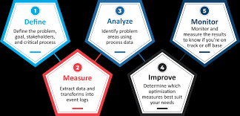

**Fig 4.1 PROCESS MINING**

Process mining is a technique designed to discover, monitor and improve real processes (i.e., not assumed processes) by extracting readily available knowledge from the event logs of information systems. Process mining includes: Automated process discovery (extracting process models from an event log)

Process mining works by extracting knowledge from event logs readily available in today's information systems, in order to visualize business processes — and their every variation — as they run. Check out how process mining works for a more detailed breakdown.

**What is process mining simple example?**

In process mining, a process is sequence of events (discrete actions) that are executed to reach a particular goal or outcome.

For example, we can characterise each patient's hospital journey as a process, starting from when they are admitted to when they are discharged.

**4.2 Process Mining Fundamentals**

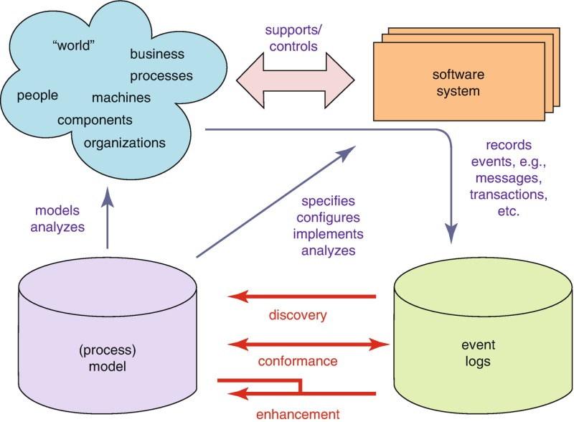

**Fig 4.2 PROCESS MINING FUNDAMENTALS**

Process mining is based on event logs. We can describe event logs as a sequence of sequences of events. In most cases, whenever the process is supported by any IT system, it produces some kind of a log of actions completed by the users. For example, the log can contain all the actions a user performed in the app

**EXAMPLE :** Let's take a sales order, for example. With traditional process mining, a customer has a relationship with their sales order. It's a one-to-one relationship. But in reality this customer has not one, but three different sales orders.

**4.3 Rising Star – Technical**

It is a part of process mining.Technical level is the most important level in the process mining

It refers to the some techniques such as new algorithms,data extraction, process discovery, conformance checking,process enhancement.

**Technical part is divided into two types :**

**1)**PQL QUERIES

**2)**GET DATA INTO EMS

4.3.1 PQL QUERIES

PQL(Procedure Query Language)Queries are an essential component of process mining.

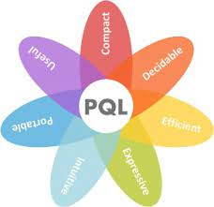

**Fig 4.3 PQL QUERIES**

Profile Query Language (PQL) is an Experience Data Model (XDM) compliant query language which is designed to support the definition and execution of segmentation queries for Real-Time Customer Profile data.

**4.3.2 Get Data Into EMS**

EMS(Event Management System)plays a crucial role in process mining.

EMS is an enterprise-ready platform for execution management that scales to thousands of business users and billions of events.

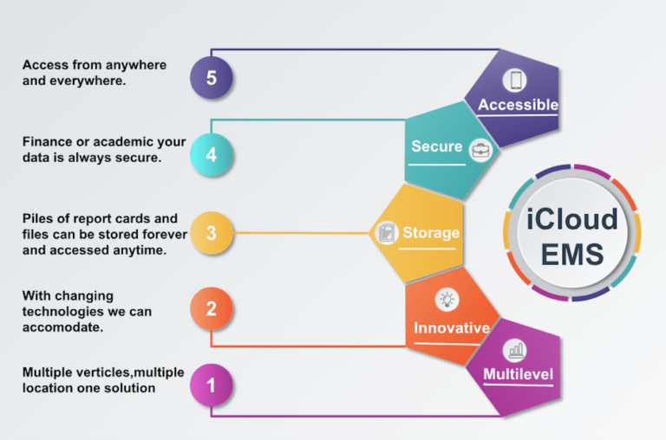

**Fig 4.4 ICLOUD EMS**

**CHAPTER 5**

**REAL TIME EXAMPLES OF PROCESS MINING**

Some examples of such activities are receiving an order, submitting a piece of documentation, approving a loan, entering information into a health record, etc. Process mining software transforms the digital records into event logs.

There are few examples of how process mining can be applied across different industries.

* **Healthcare centers** : process mining can be used to analyze patient care pathways and identify bottlenecks or inefficiencies in hospital workflows.It can help optimizwe patient flow, reduce waiting times, and improve resource allocation.
* **Manufacturing** : Process Mining can be applied to analyze production processes and identify areas for improvement.
* **Finance** : process Mining can be used to analyze finanacial processes,such as invoice processing or loan approvals.
* **Banking** : In process Mining To deposit the money or to retrieve the money the process is used.

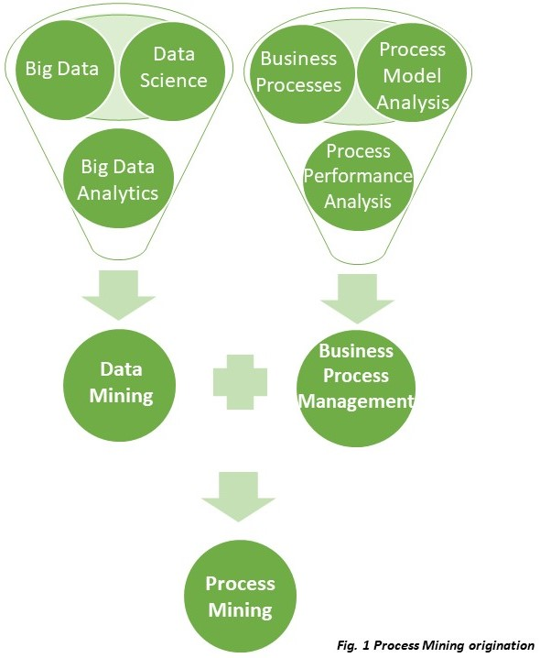

**Fig 5.1 REAL TIME EXAMPLE OF PROCESS MINING**

**CHAPTER 6**

**Learning outcomes of the Process Mining**

* **Performance Monitoring :** Process Mining is **a** Performance monitoring involves the measurement of performance over time against indicators of performance or key performance indicators (KPIs)
* **Process Discovery :** the term 'process discovery' refers to a set of tools that provide a systematic way to identify, map, define, and analyze business processes and the activities and tasks they are comprised of.
* **Advantages Of Process Mining**

The use of process mining and execution management can deliver a variety of benefits to government agencies: increasing efficiency of existing tech investments while modernizing current systems and processes; raising visibility into siloed tech stacks; reducing process complexity; and delivering cost savings.

* Reduced Costs
* Improve Customer Efficiency
* Compliance Benefits
* General Business Benefits
* **Disadvantages Of Process Mining :**
* Process mining can only analyze past performance, lacking the ability to monitor processes on an ongoing basis and to alert users to deviations.
* Some traditional process mining tools may be limited in the typesof data sources they can connect to,which can limit the value they can provide.

**CONCLUSION**

* process mining can be a powerful tool for improving the efficiency and effectiveness of business processes, and is increasingly used by organizations to drive process improvement efforts.
* Process Mining is a powerful technique that enables organizations to analyze and improve their processes.
* Process Mining Fundamentals include data extraction, data transformation, and data visualization.These fundamentals elements are essential for effectively applying process mining techniques.
* Raising Star technical topics in process mining,such as PQL Queries and getting data into EMS,Further enhance the capabilities of process mining.